**Create & Manage Projects**

Setup your project and add all details for your team and client by giving a brief about the project, set the budget, start date, project duration, and select who should have access to the project from your team and client users.

[Manage Your Projects](https://wppacks.com/product/wordpress-portal/#inner-page)

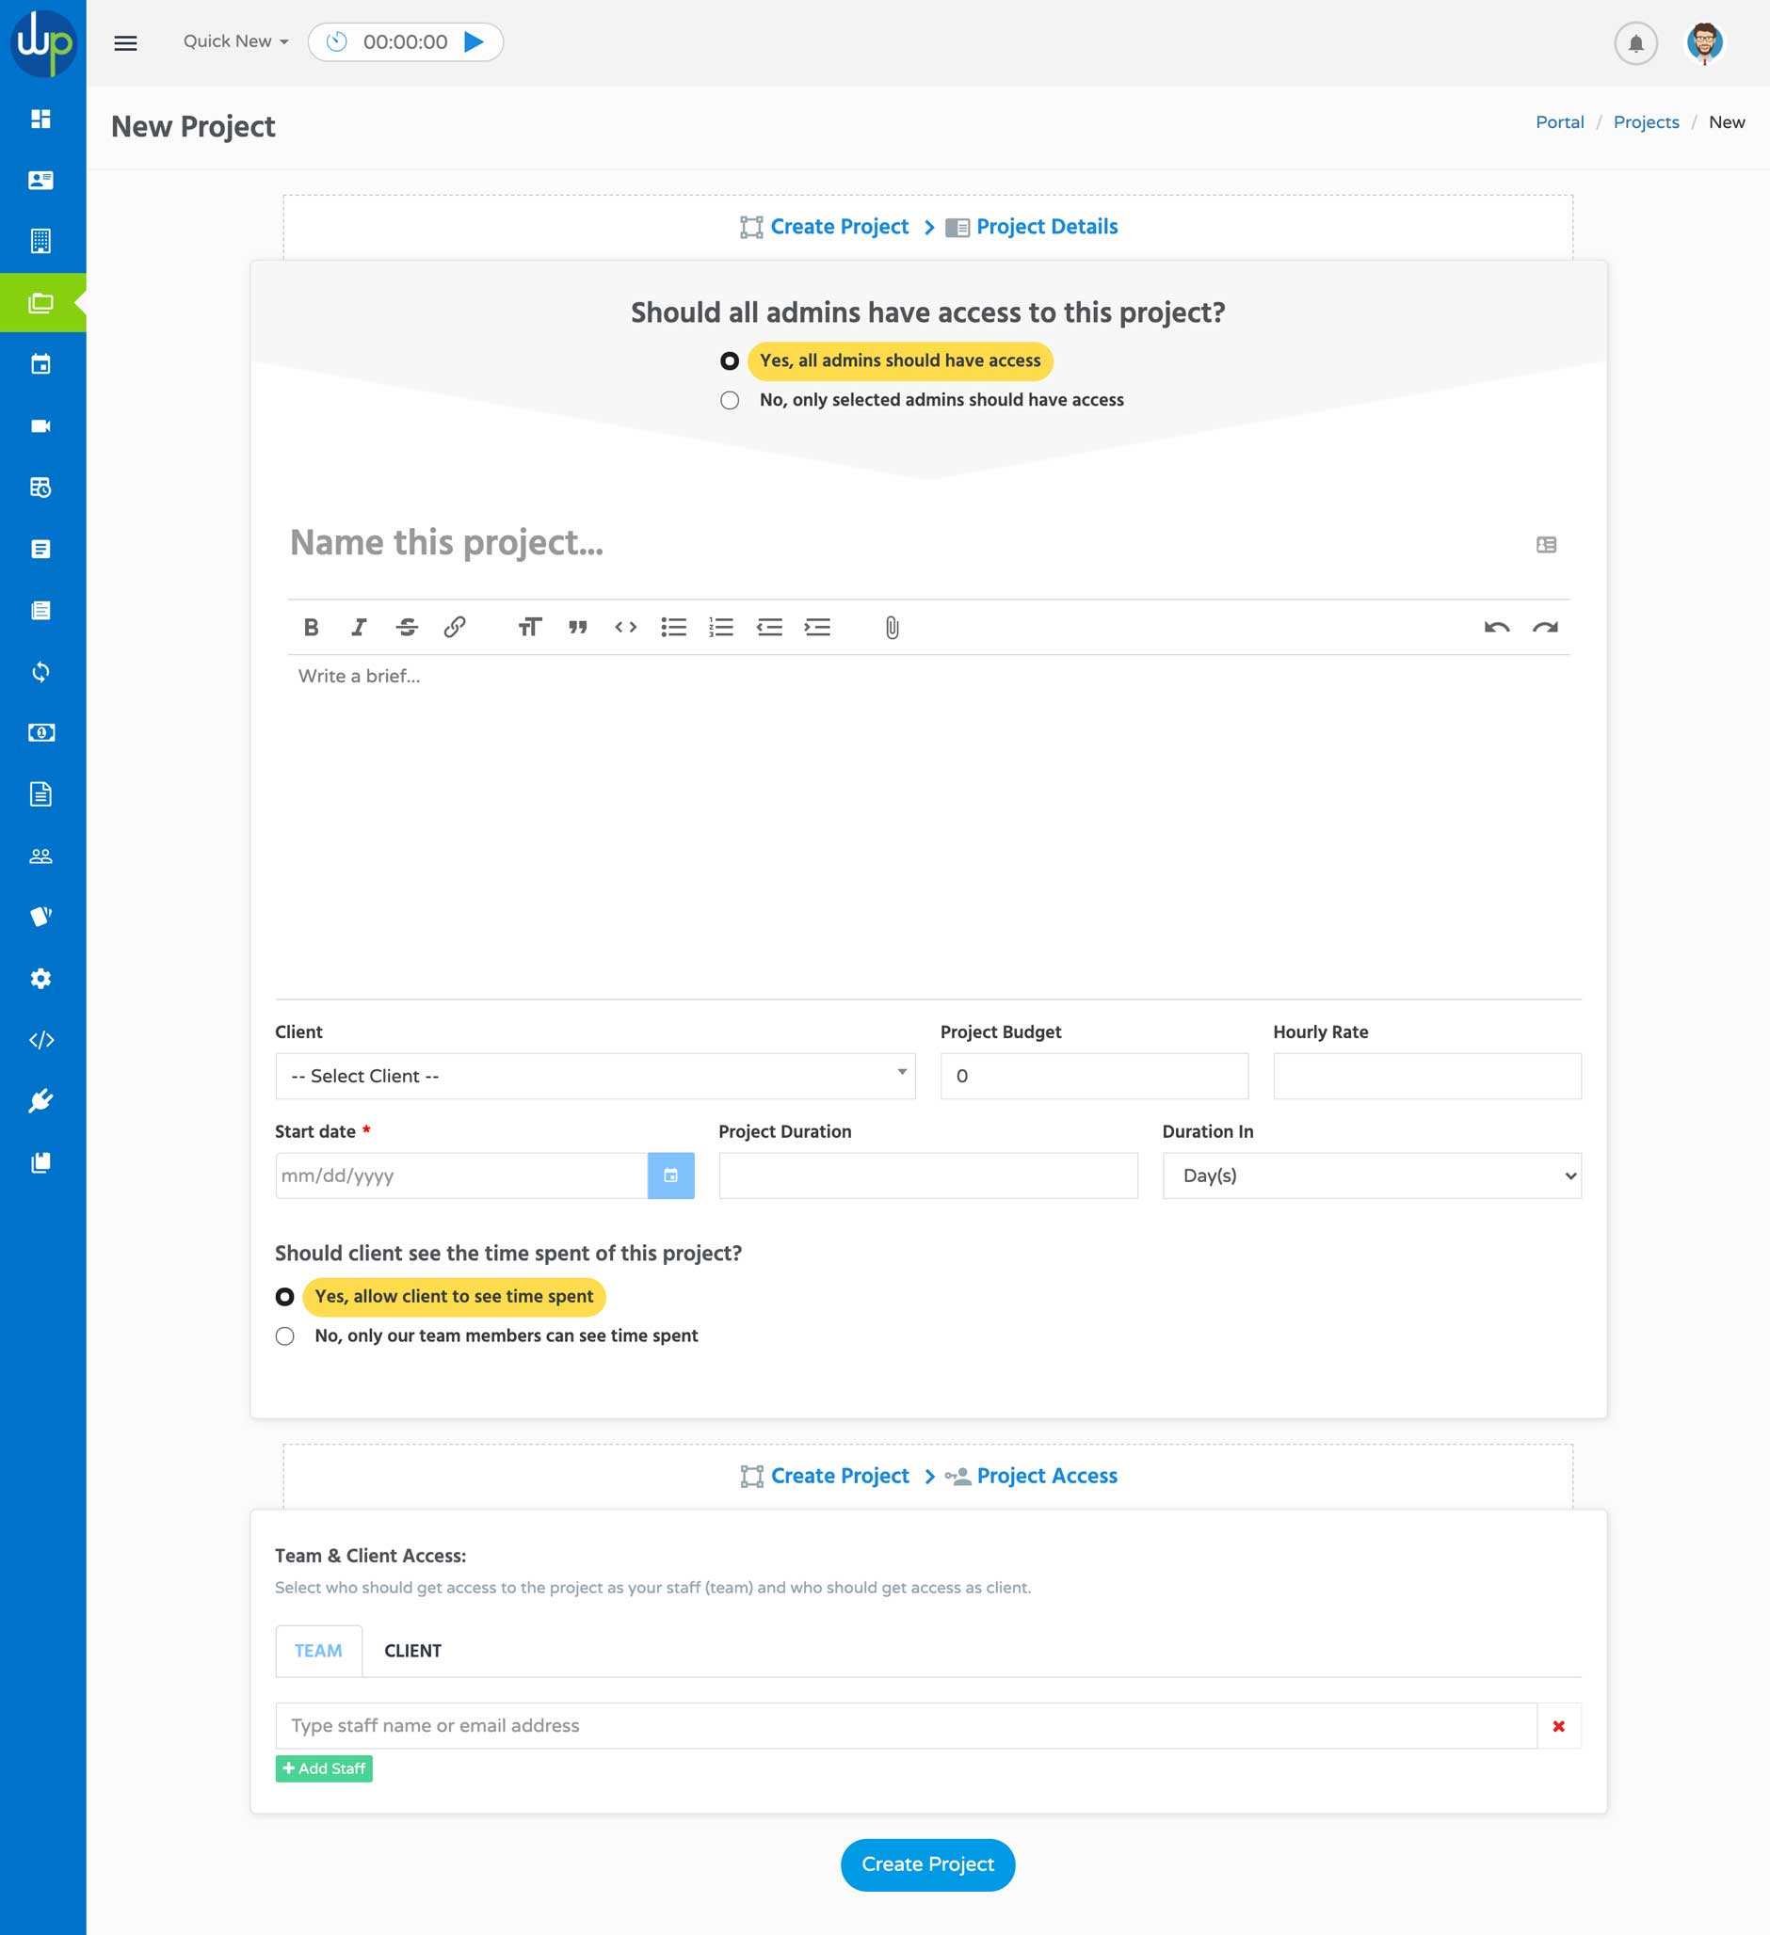

**Assign Tasks & Milestones**

Keep your client and team about the project progress by adding and updating milestones for the project and assigning tasks to your team by setting a due date and priority. Use the Kanban board to track the progress of the assigned tasks.

[Manage Tasks Now](https://wppacks.com/product/wordpress-portal/#inner-page)

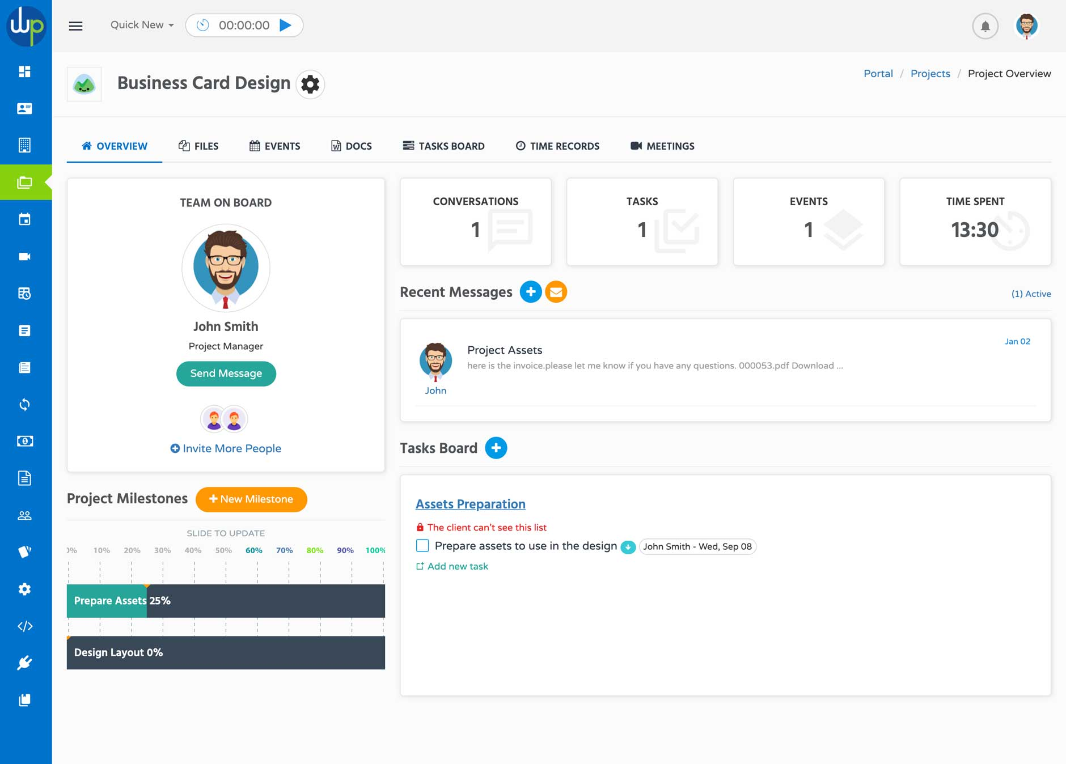

**Track Time & Generate Timesheets**

Use the time tracking tool to track your time and allow your team to track their time for each project and task. Then generate timesheets based on a specific period so you can pay your team and generate invoices to your client.

[Start Tracking Time](https://wppacks.com/product/wordpress-portal/#inner-page)

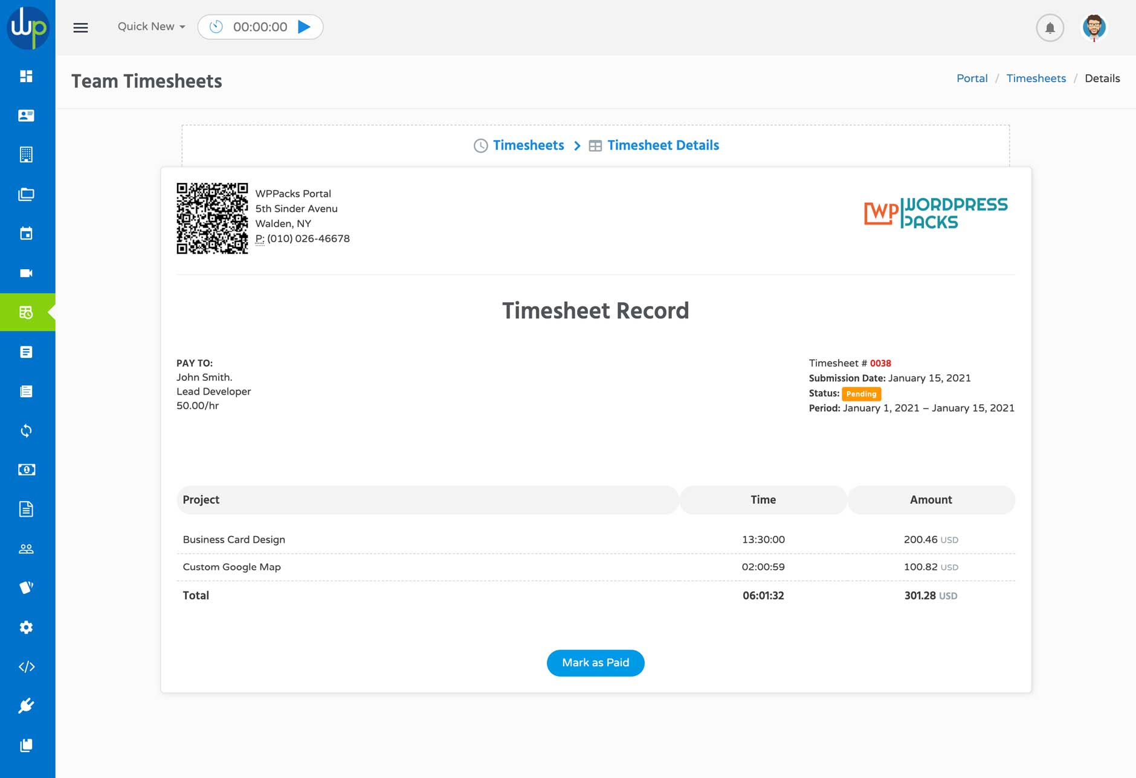

**Schedule Events & Meetings**

Create project events using the project events calendar inside the project and share them with your team. You can also schedule and join **ZOOM** meetings without leaving the dashboard using our new Zoom Meetings extension.

[Start Scheduling Now](https://wppacks.com/product/wordpress-portal/#inner-page)

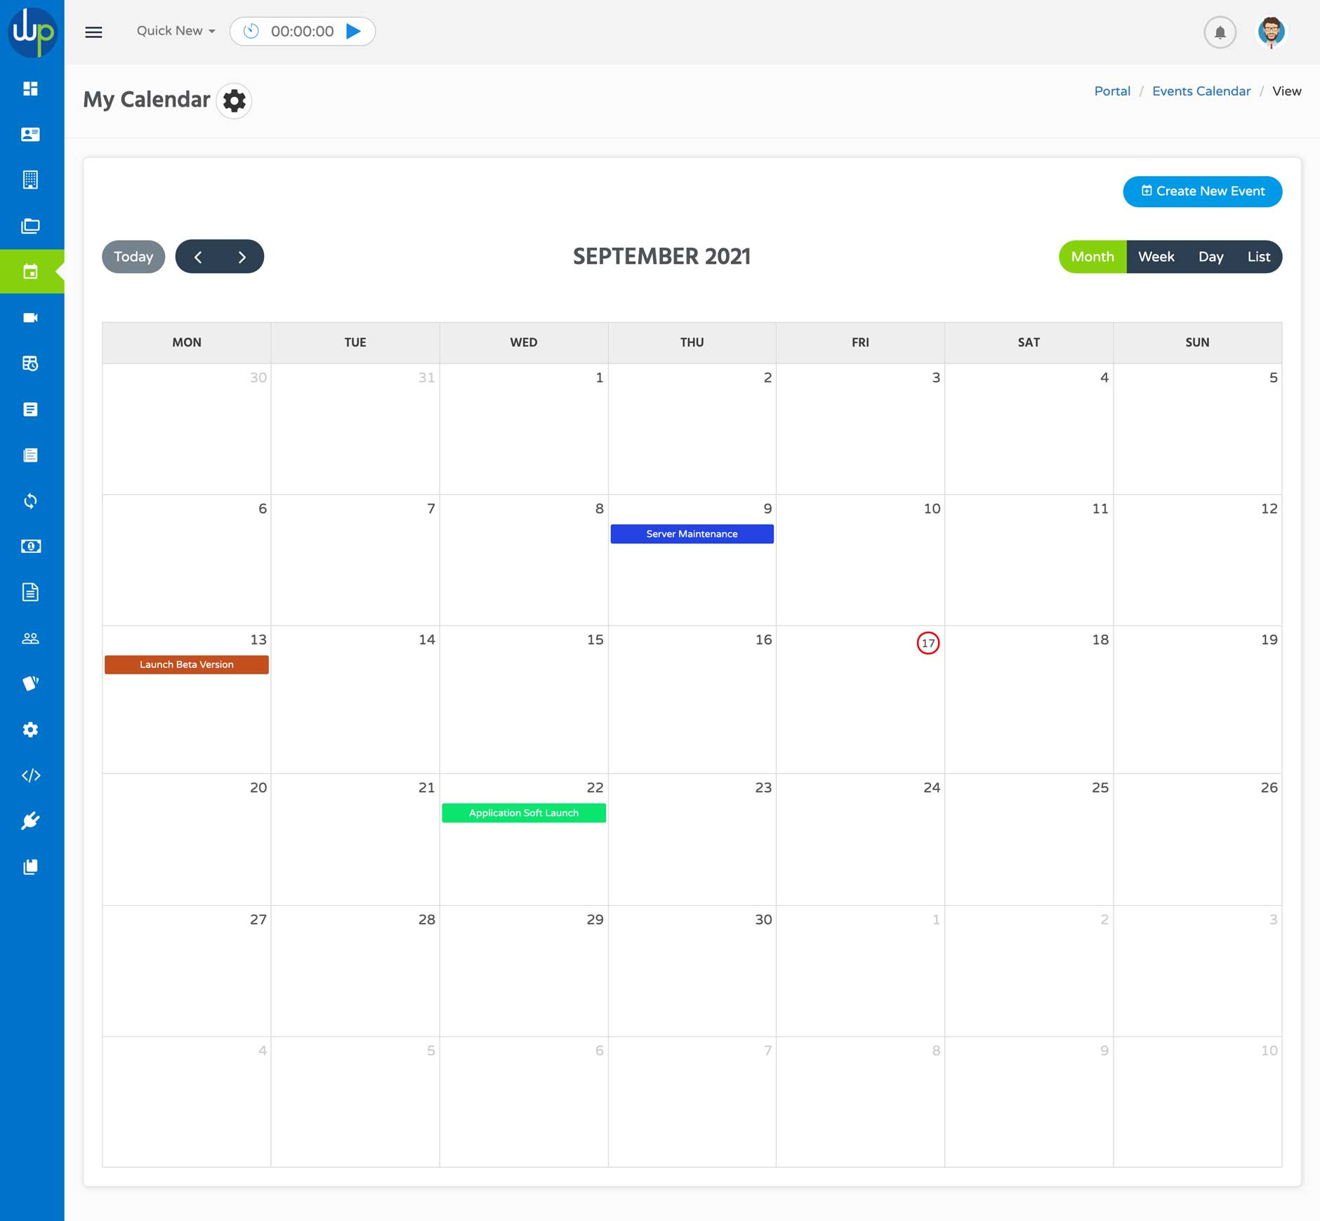

**Create & Share Wikis**

Use the project wikis to create documents and notes for your project and share them with your team and client. Anyone who has access to the project can create and share documents with other users in same project.

[Share Your Documents](https://wppacks.com/product/wordpress-portal/#inner-page)

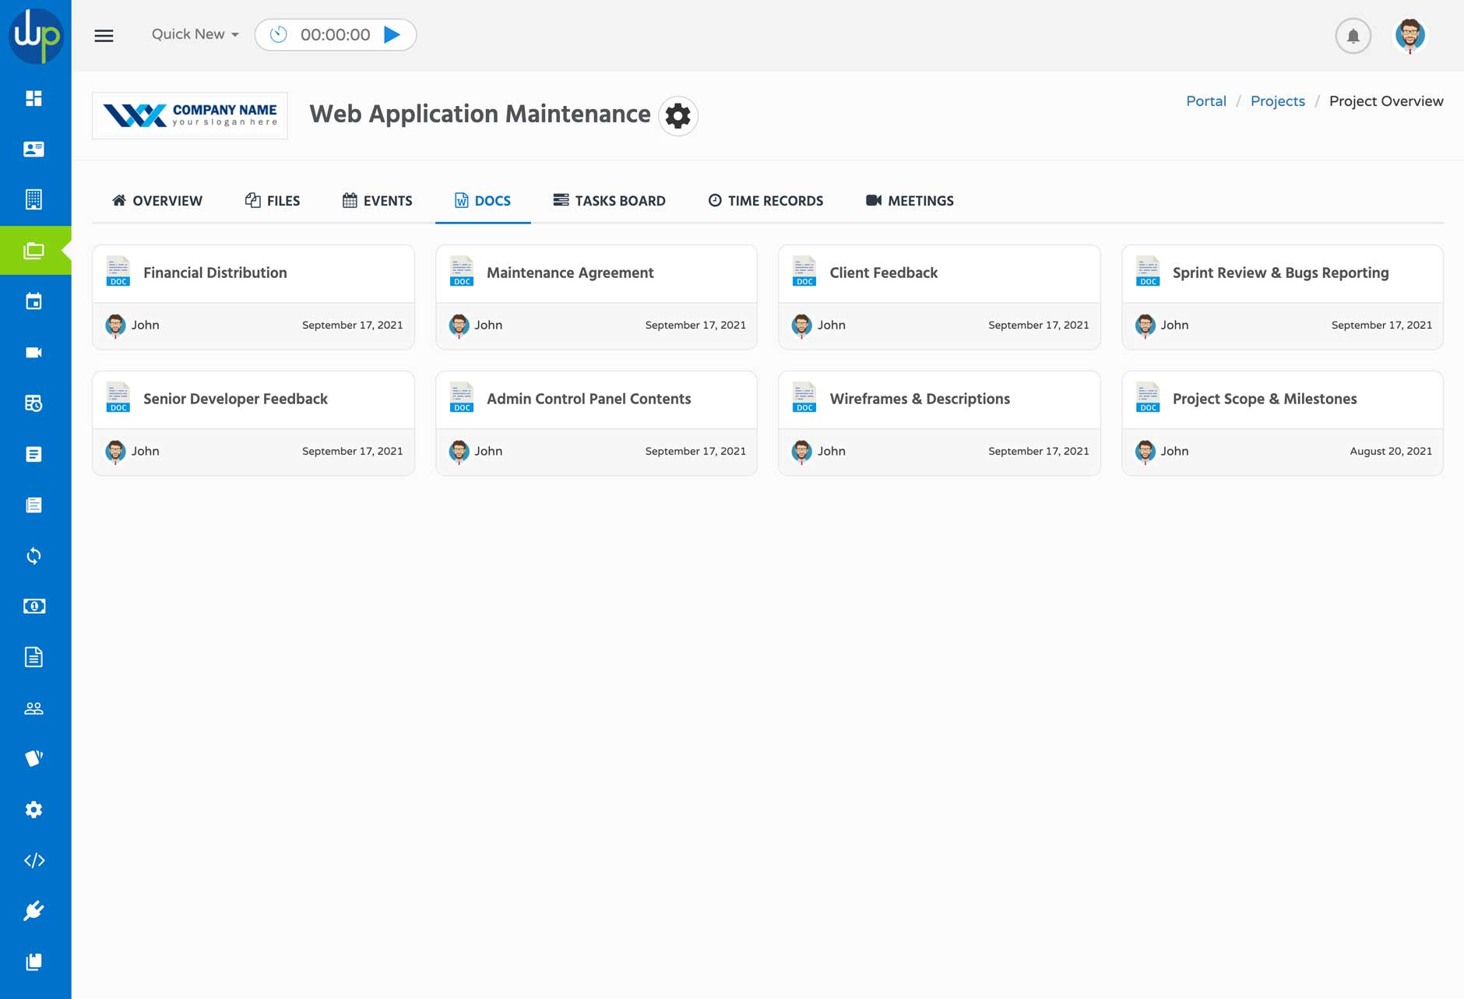

**Upload Files & Share Comments**

Using your cloud or local storage, upload your project files in one place and share them with everyone who has access to the project. Add & share comments with your team and clients on every single file you upload.

[Handle Your Files](https://wppacks.com/product/wordpress-portal/#inner-page)

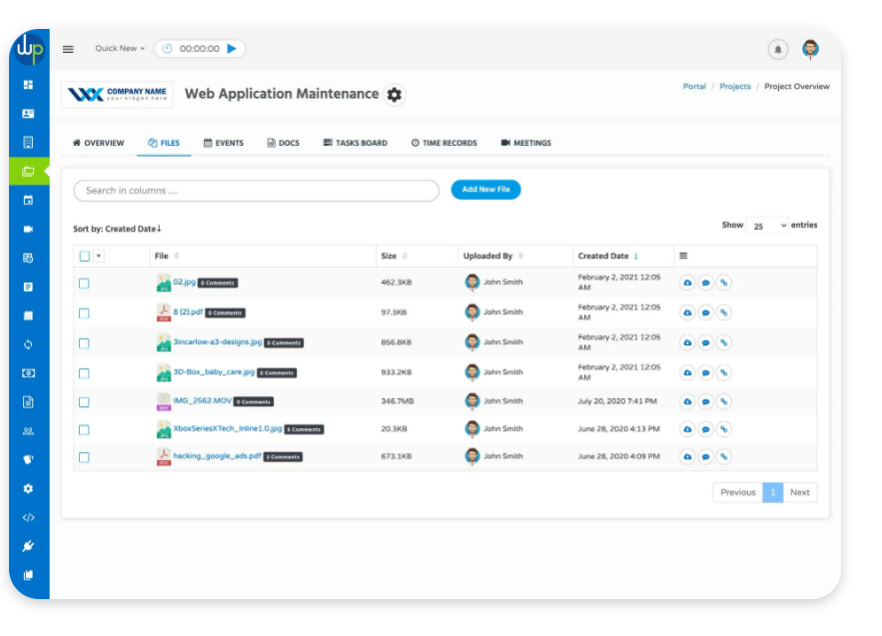

**Send & Reply to Messages**

Stay in touch with your team and clients by using the message threads inside each project to keep everything organized. Send messages and reply to messages from your team and client. Set private threads where clients cannot access for internal discussion with your team members only.

[Start Conversations](https://wppacks.com/product/wordpress-portal/#inner-page)

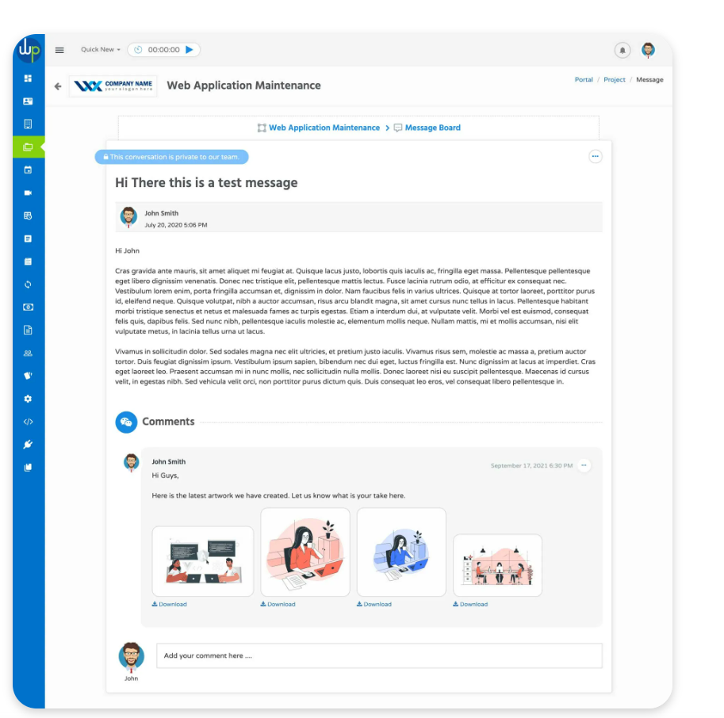

**Prepare & Send Estimates**

Get more projects & requests from your clients using the estimate form builder. Build forms around your different services and let your clients use these forms to get quotes and estimates from you about a service they want then convert the request to estimate and later as invoice.

[Create & Send Estimates](https://wppacks.com/product/wordpress-portal/#inner-page)

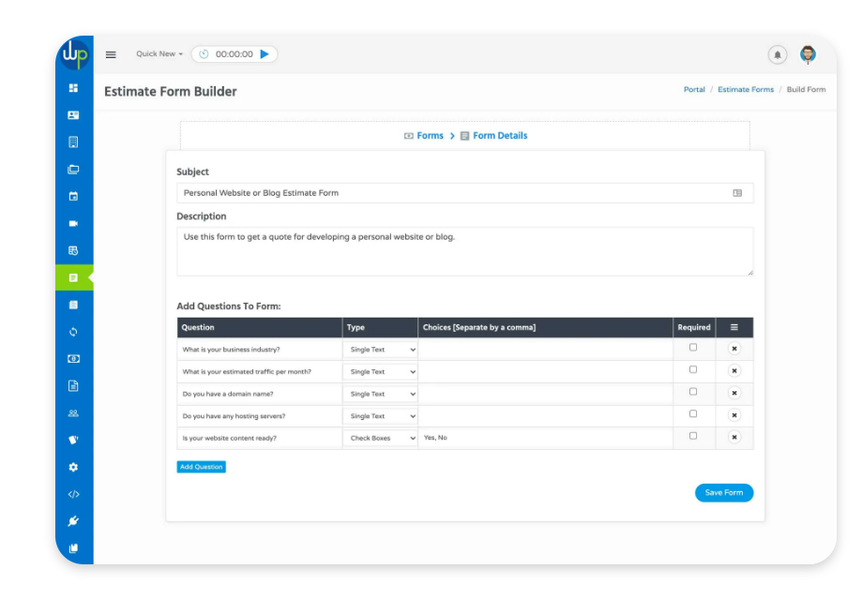

**Send Invoices & Get Paid**

Create one-time and recurring invoices for your client and allow them to make payments online using their credit cards or PayPal account. Give your client the flexibility to make a full payment or partial payment of the invoice.

[Send Invoice & Get Paid](https://wppacks.com/product/wordpress-portal/#inner-page)

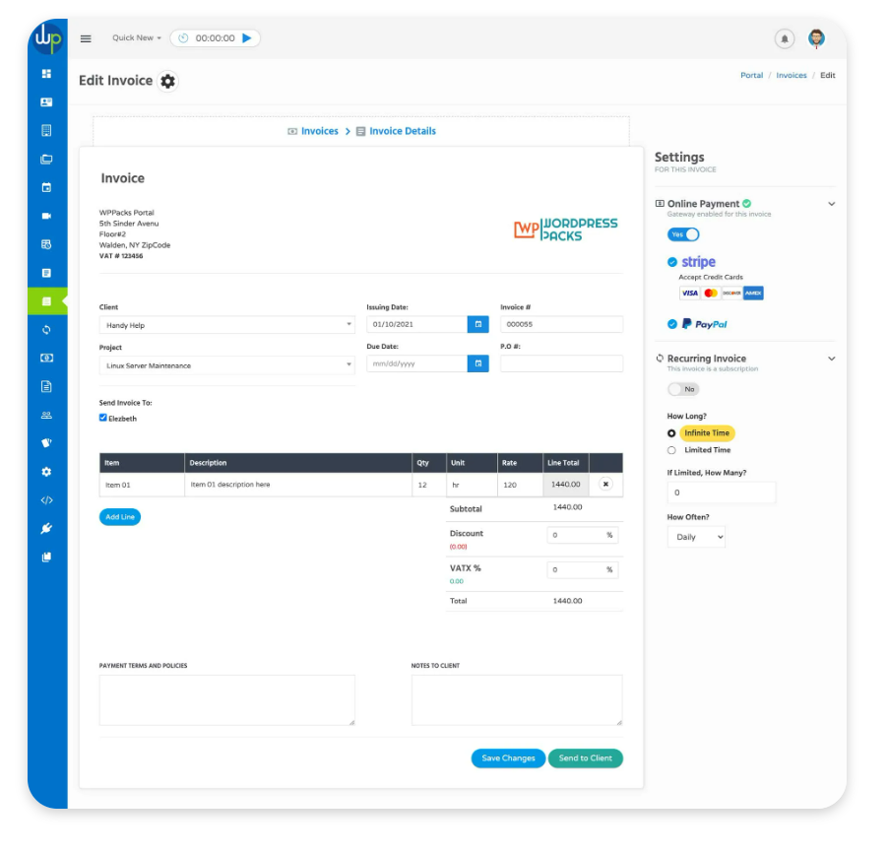

Finally I want to have a statistics section for Financial statistics and view statistics

